Analysis Of The Digital Gap In Madrasah Aliyah Fatwa Alim

Mukhlish Imam Rofiqi¹, Januar Haidar Saddad², Adevina Dwi Ningtias³
¹ Universitas Islam Negeri Kiai Ageng Muhammad Besari Ponorogo
² Universitas Islam Negeri Kiai Ageng Muhammad Besari Ponorogo
³ Universitas Islam Negeri Kiai Ageng Muhammad Besari Ponorogo

januarhaidar8@gmail.com, mukhlishrofiqi@gmail.com. adevinadwi2@gmail.com

Article history |  | Submitted: xxxx/xx/xx; Revised: xxxx/xx/xx; Accepted: xxxx/xx/xx
Abstract |  | The digital divide is one of the main challenges in developing a technology-based society in the current era of digital transformation. This study aims to analyze the digital divide in the school environment. This study used a quantitative approach through a questionnaire sent to the school. The target of this study were several teachers involved and participating in learning activities at Madrasah Aliyah Fatwa Alim. The results showed that the majority of teachers and students at the school have implemented digital technology, and only a small number have not yet understood it. However, there are also students who do not yet understand technology and are lagging behind their peers who are familiar with it. The school has provided digital-based supporting facilities to provide convenience for students and encourage them to be more active in learning.
Keywords |  | The digital divide; digital transformation; Madrasah Aliyah;
 |  | © 2025 by the authors. This is an open access publication under the terms and conditions of the Creative Commons Attribution 4.0 International (CC BY SA) license, https://creativecommons.org/licenses/by-sa/4.0/.

INTRODUCTION
In this modern era, numerous changes have impacted our lives. One such change is the advancement of information and communication technology (ICT). Today's life is inextricably linked to technology, whether it's access to information, transportation, or anything else. The learning process is no exception; technology has begun to permeate the educational sector, significantly impacting both teachers and students. One example is the breadth of learning resources that students can easily access, enabling learning to be no longer teacher-centered and allowing them to access materials via the internet or other media. (Yayat D Hadiyat: 81) Therefore, the role of teachers goes beyond providing material and also guiding students to prevent misuse of technology. Current technological developments, particularly in education, are not without challenges and problems. A common challenge is the continued lack of ICT infrastructure in many areas, particularly in eastern Indonesia. The continued lack of telecommunications services in many parts of Indonesia is understandable, given its vast land area of approximately 7.9 million km². Furthermore, Indonesia is an archipelagic nation comprising more than 13,000 islands, with many areas consisting of mountains and valleys. This situation results in rural areas being scattered across various regions, making the development of communication and information infrastructure difficult and costly. As a result of the large number of areas in Indonesia lacking ICT infrastructure, a new problem has emerged: the digital divide. The term "digital divide" remains a matter of debate. According to the National Telecommunications and Information Administration (NTIA) under the United States Department of Commerce (1999), the digital divide arises from significant differences in access to and utilization of digital technology, preventing everyone from accessing new technologies. Meanwhile, Onitsuka et al. (2018) explain that the digital divide is the inequality experienced by some communities in accessing and using digital technology, which makes it difficult for them to use the technology or to become less skilled at using it. (Jayanti and Dinaseviani: 2022) According to Raharjo (2003), the digital divide is caused by several factors, including limited access to infrastructure such as electricity, telecommunications networks, and technological devices. low human resource skills, both individually and in communities; a lack of relevant content or materials; and minimal government support or incentives. Furthermore, the digital divide can also be used as a measure of a country's progress, as it demonstrates differences in access to information sources, both between countries and between regions within a country (Syopiansyah: 2009).
Based on these issues, a study was conducted to identify and analyze the digital divide in schools in remote areas, specifically the Fatwa Alim Islamic Senior High School in Tulung Village, Saradan District, Madiun Regency. This research is expected to address the digital divide in Indonesia and ensure equitable distribution of technology across all regions, particularly in the education sector.

METHODS
This research was conducted using a descriptive quantitative method, utilizing a questionnaire. According to Creswell (2013), quantitative research is an approach conducted in a planned, objective manner by collecting and analyzing numerical data. This numerical data is used to obtain accurate, relevant, and reliable information in understanding a particular phenomenon or problem. (Damanik: 2025). This research was conducted at the Fatwa Alim Islamic Senior High School located in Tulung Village, Saradan District, Madiun Regency. The study was conducted in early November 2025. The target group was teachers participating in the school's learning process, with a sample size of 13. The research stages included data analysis, data presentation, and verification.

FINDINGS AND DISCUSSION
In today's era, increasingly global technological advances have had a significant impact on various aspects of life, such as politics, economics, culture, art, and even education. Technological development is unavoidable, as it goes hand in hand with scientific progress. In education, technology plays a crucial role, particularly in the development of science. Students not only learn about natural phenomena and facts but also utilize technology to apply and develop that knowledge in their daily lives. When technology is used in education, problems arise during the learning process. One is the digital divide, which impacts the learning process and student motivation. Therefore, this research was conducted, yielding the following results
- Use of technology in learning by teachers/educators
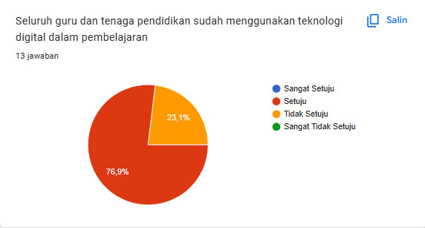
The diagram above shows that 23.1% of teachers at the school have not yet used technology in their learning, while the rest have. This indicates that technology in the school is starting to develop evenly, although it is still limited.The text continues here.
- The impact of technology on student understanding
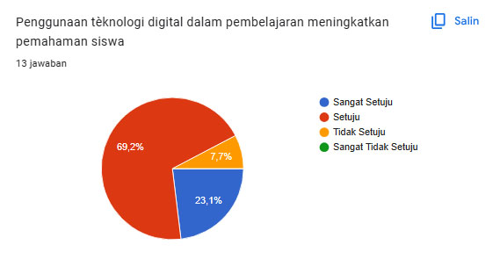
The diagram above shows that the majority of students understand the learning material presented by the teacher using technology media. Only 7.7% of students still have difficulty understanding learning using technology media.
- Teachers' ability to utilize technology
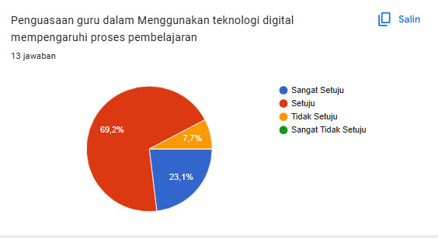

The diagram above shows that most teachers at the school are already technologically savvy and can utilize it in the learning process. The use of technology will also impact the learning process.
4. Availability of school facilities and infrastructure in the field of technology
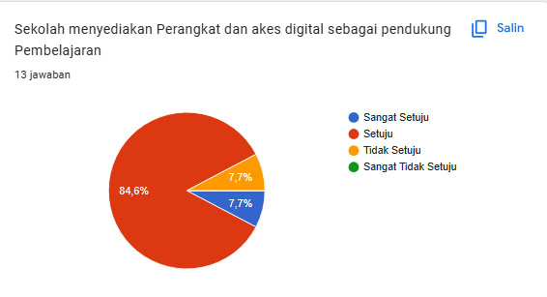
The diagram above shows that the school has provided digital technology-based support facilities to support the learning process. These support facilities further assist students in the learning process, which utilizes digital technology as a medium.
Based on the research results above, Madrasah Aliyah Fatwa Alim Saradan has utilized technology in the learning process. Most of the school's human resources are familiar with and have mastered technology. Therefore, by utilizing digital technology in the learning process, students can better understand the material presented, and teachers can more easily provide more detailed and comprehensive explanations.
CONCLUSION
Based on the discussion of this material, it can be concluded that advances in information and communication technology have had a major influence on education, but have not been felt equally by all parties. Indonesia's vast, archipelagic geography, limited infrastructure, low human resource skills, lack of digital learning content, and lack of government support are the main factors in the emergence of the digital divide. The research results show that although the majority of teachers and students have used technology in the learning process, a small number have not been able to use it effectively. This digital divide affects differences in students' understanding and motivation to learn. Therefore, continued efforts are needed from schools and the government to increase equitable access to technology, strengthen the digital competence of educators and students, and provide adequate facilities and infrastructure so that the use of technology in education can run effectively and evenly

REFERENCE
Damanik, Muhammad Rafiqi, Randy Luther Manik, dan Muamar Khadafi. “METODE PENELITIAN KUANTITATIF: KONSEP, JENIS, TAHAPAN DAN KELEBIHAN.” JIIC: Jurnal Intelek Insan Cendikia 2, no. 7 (2025): 13479–96.
Hadiyat, Yayat D. “Kesenjangan Digital di Indonesia (Studi Kasus di Kabupaten Wakatobi).” Jurnal Pekommas 17, no. 2 (2014): 81–90.
Jayanthi, Ria, dan Anggini Dinaseviani. “Kesenjangan Digital dan Solusi yang Diterapkan di Indonesia Selama Pandemi COVID-19.” JURNAL IPTEKKOM Jurnal Ilmu Pengetahuan & Teknologi Informasi 24, no. 2 (2022): 187–200. https://doi.org/10.17933/iptekkom.24.2.2022.187-200.
Maritsa, Ana, Unik Hanifah Salsabila, Muhammad Wafiq, Putri Rahma Anindya, dan Muhammad Azhar Ma’shum. “Pengaruh Teknologi Dalam Dunia Pendidikan.” Al-Mutharahah: Jurnal Penelitian dan Kajian Sosial Keagamaan 18, no. 2 (2021): 91–100. https://doi.org/10.46781/al-mutharahah.v18i2.303.
Putra, Syopiansyah Jaya. “DIGITAL DIVIDE: IMPLIKASI SOSIAL EKONOMI PERKEMBANGAN TEKNOLOGI INFORMASI DAN KOMUNIKASI.” Studi Informatika: Jurnal Sistem Informasi 2, no. 1 (2009): 33–38.

